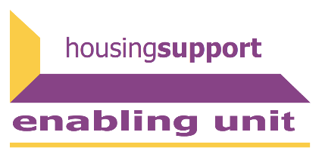

National Care Service (Scotland) Bill
Housing support and the NCS
The National Care Service (Scotland) Bill was introduced to Parliament on 20 June 2022 [1]. The Bill is currently in Stage 1 and a consultation has just concluded.
The principles of the National Care Service focus on building a service that allows the realisation of human rights, centres on early intervention, and that is designed collaboratively. Housing services under the Housing Act are not included within the scope of the National Care Service. This includes functions related to homelessness. However, the policy memorandum [2] recognises that
‘…the NCS will need to work closely with housing and homelessness services to ensure people’s needs are met.’
The policy memorandum also suggests that the NCS will be subject to the shared homelessness prevention duty and will be involved in joined up planning to tackle homelessness.
Other functions of housing support are not mentioned within the NCS Bill or Policy Memorandum, suggesting that they will not be included within the scope of the National Care Service. However, areas and services that often intersect with housing support are included in the NCS including responsibility for Adult Support and Protection, mental health services, alcohol and drugs support, and Social Work. This is important because housing support is often a collaborative effort with joint funding streams involving Social Work and Housing.
Concerns of housing support providers
- How will providers maintain the ability to work collaboratively with other social care services, especially with joint funding streams such as through social work?
- Providers of housing support have fundamental concerns that structural changes will not improve front-end services. Culture change and adequate funding are required.
- The current state of the bill as framework legislation means that essential details will be dealt with in secondary legislation and there are worries that a level of scrutiny has been removed.
- Relationship between the NCS and local government is an area of concern. Will the NCS still be able to foster accountability at local level and how will care boards practically be different from local authorities and Integrated Joint Boards?
Responding to the consultation
The Unit contributed to both the CCPS and SFHA responses and will continue engaging with the sector as the Bill progresses through Stage 1 and beyond.
The principles of the Bill look promising for bringing positive change to social care and support. They emphasise the importance of human rights, early intervention, and collaborative design. However, without a model of change targeting the primary change drivers of culture, relationships, and behaviours, it is not clear how the principles will be followed through.
CCPS has created a model of change for social care and support in Scotland. Beginning with a similar overarching vision to the National Care Service, this model includes system requirements, behaviours, resources, and operating principles that are necessary to enable change within social care and support that would meet the principles outlined in the NCS Bill.
You can find the CCPS response to the consultation here and the SFHA response here.
[1] https://www.parliament.scot/bills-and-laws/bills/national-care-service-scotland-bill/stage-1.
[2] https://www.parliament.scot/-/media/files/legislation/bills/s6-bills/national-care-service-scotland-bill/introduced/policy-memorandum-accessible.pdf

